IMPORTANT VENUE INFORMATION
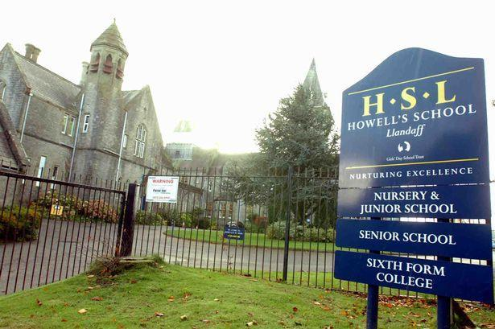

Date of Market: Saturday 5th October 2019
Address: Howells School Sports Hall
Cardiff Road
Cardiff
CF5 2YD

Market open to the public: 11.00am – 12.30pm

Arrival time for stallholders: 10.00am

Packing up time for stallholders: 12.30pm – 1.00pm

Tables: We provide the tables. Please bring a table covering, as the quality of tables
provided by venues may differ.

Please note that each stallholder is allocated their own table before the event, so there is
no need to arrive extra early to secure your place. Just give us your name when you
arrive and we’ll tell you which table is yours.

Clothes Rails: You are welcome to bring up to 2 of your own rails, as long as they are
of a reasonable size (no longer than 3 ft).

Kidsmarkets have a limited number of clothes rails available for hire. Please reserve
prior to the market. Cost - £3 payable on the day. We do not provide hangers.

Parking: Plenty of free parking in the school car park.

Loading / Unloading: Items should be loaded through the doors and down a corridor into the hall. Look out for the signage to show you where to go!

Directions: Click here for google map

Howell’s School entrance is on the A4119 Cardiff Road, which can be reached off the A48 Western Avenue or Cathedral Road/ Penhill Road if coming from Cardiff city centre.

ARE YOU NEW TO KIDSMARKETS?
Please visit the stallholders area of the website before the event, and download the
appropriate advice sheet for your type of stall. These include advice and information
about setting up your stall, dos and don'ts on the day, and the ways to make the most
out of your Kidsmarkets experience.

Please give Tamsin a call on 07760 802088 if you have any questions or queries
beforehand, or on the day.

